**Artificial Intelligence Assignment #1**

Due date: Wednesday, 8, March 2017, 11:55 pm

for students in waiting list: Friday, 10, March 2017, 11:55 pm

No Late Submission

**Programming Language:**

* Python 3.6
* There is no external library required for this assignment.
* Possible to use any IDE.

**Given Code:**

* In YSCEC -> Notice board, you will find Assignment #1 that includes this instruction document and a given code “assignment1.py”
* There are total three classes and one main function written in the given python code.

**Given Class Information:**

* SudokuUI: Class for Sudoku GUI. Initialize GUI settings.
* Problem: Class which includes Sudoku question and answer.
* SudokuSolver: Class contains “solver” function that needs to be completed.

**Assignment Information:**

* Solve regular Sudoku puzzle by using DFS-based search algorithm.
* You can use any search algorithm to solve the problem.
* Total two problems given (Easy and Normal).
* There is two buttons you can select form the UI. You can select the button to start the Sudoku solver for each problem.
* Need to check constraints. Check out the picture below. Red boxes are example of constraints.

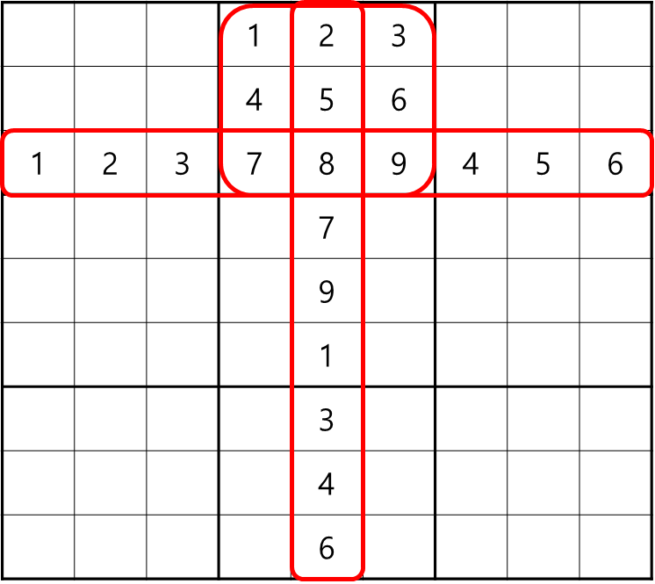

**Need to Do:**

* In “SudokuSolver” class, there is “solver” function. You need to add your search algorithm code in this function.
* It is okay to add any new class or function, but always need to start from “solver” function.
* It is required to call “display(i, j, k)” function to display your process in the UI. Parameter means in position (i, j) insert value k.
* If you call “display(i, j, “”)”, the position (i, j) will be empty.
* Example: If you are searching a value in position (1,3) with value 2 already inserted, and trying numbers 3~5. You need to initialize the cell to clear out the existing number in the position (1,3). display(1,3,””) 🡪display(1,3,3) 🡪 display(1,3,4) 🡪 display(1,3,5).

**How to test:**

* In your UI, you will find “Easy” and “Normal” buttons. If you click on each buttons, you will be able to see how your algorithm works.
* After your code is done, you will see a message. “Correct” means your code finished successfully by finding all correct answer. “Fail” means your code find some wrong answers, so you might have to fix your code.

**Submission:**

* Submit your python file in YSCEC -> Assignment #1
* Please write your name and university number at the top of python code. (There is a section in the top section of .py file.)
* Change your file name to be your university number. (ex. 2012123123.py)

**No Late Submission Penalty:**

* If you submit after the due date, there will be 0 point.

**Download:**

* Python 3.6.x.x : <https://www.python.org/downloads/>